BEST PRACTICE
Development of an eco-friendly environment
The Context-
Proper waste disposal and management can be done by applying the 3R – Reduce, Reuse and Recycle. Reducing means lessening the amount of trash/garbage produced. Reusing refers to using materials more than once while recycling means creating new material or product out of trash/garbage.

Objectives-
Generating awareness about cleanliness in the campus and co-operate in Swachh Bharat mission.

The Practice

- Solid waste management is practised to safely dispose the waste generated at the institution by way of segregating the waste as biodegradable and non-biodegradable waste
- Two bins at each corner are placed for waste collection for non-biodegradable and degradable waste collection of waste from the campus is done through a tractor provided by Nagar Nigam office
- Liquid waste is generated from Science laboratories,

- The chemistry department uses containers for the disposal of waste . Waste water from the basin of the laboratories are collected in a 1500 litre capacity tanks and treated to neutralise the collected water and reused in garden The 5-gallon carboys provided by the college is used for the disposal of organic waste.

- To Reduce paper waste priority is given to paperless work and reuse of paper for printing

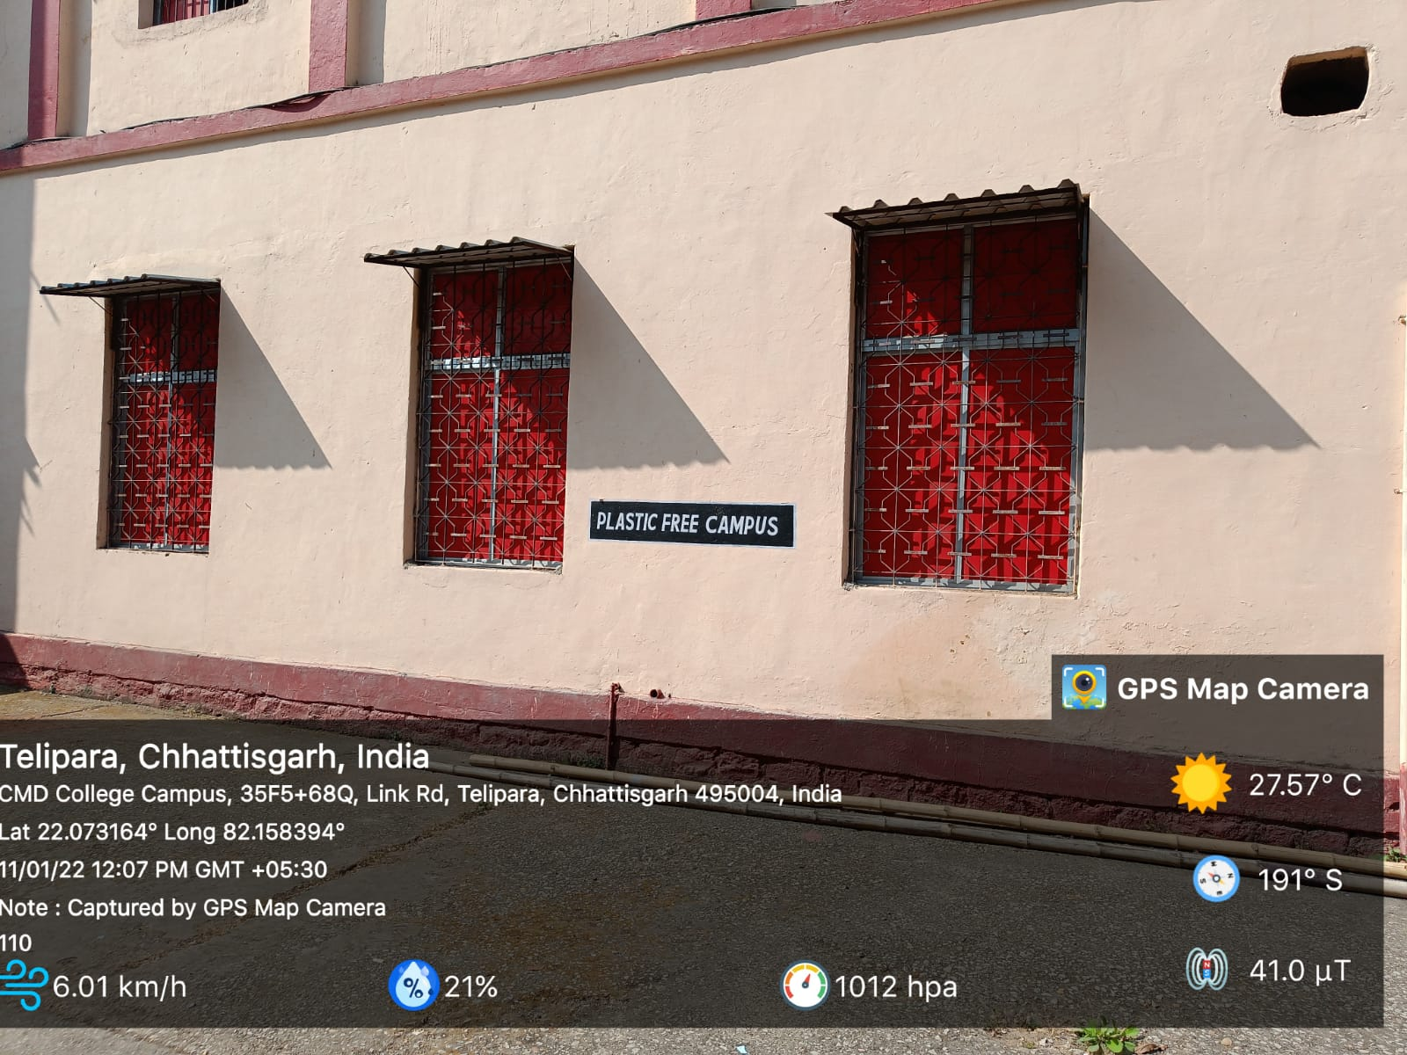

PLASTIC BANED CAMPUS

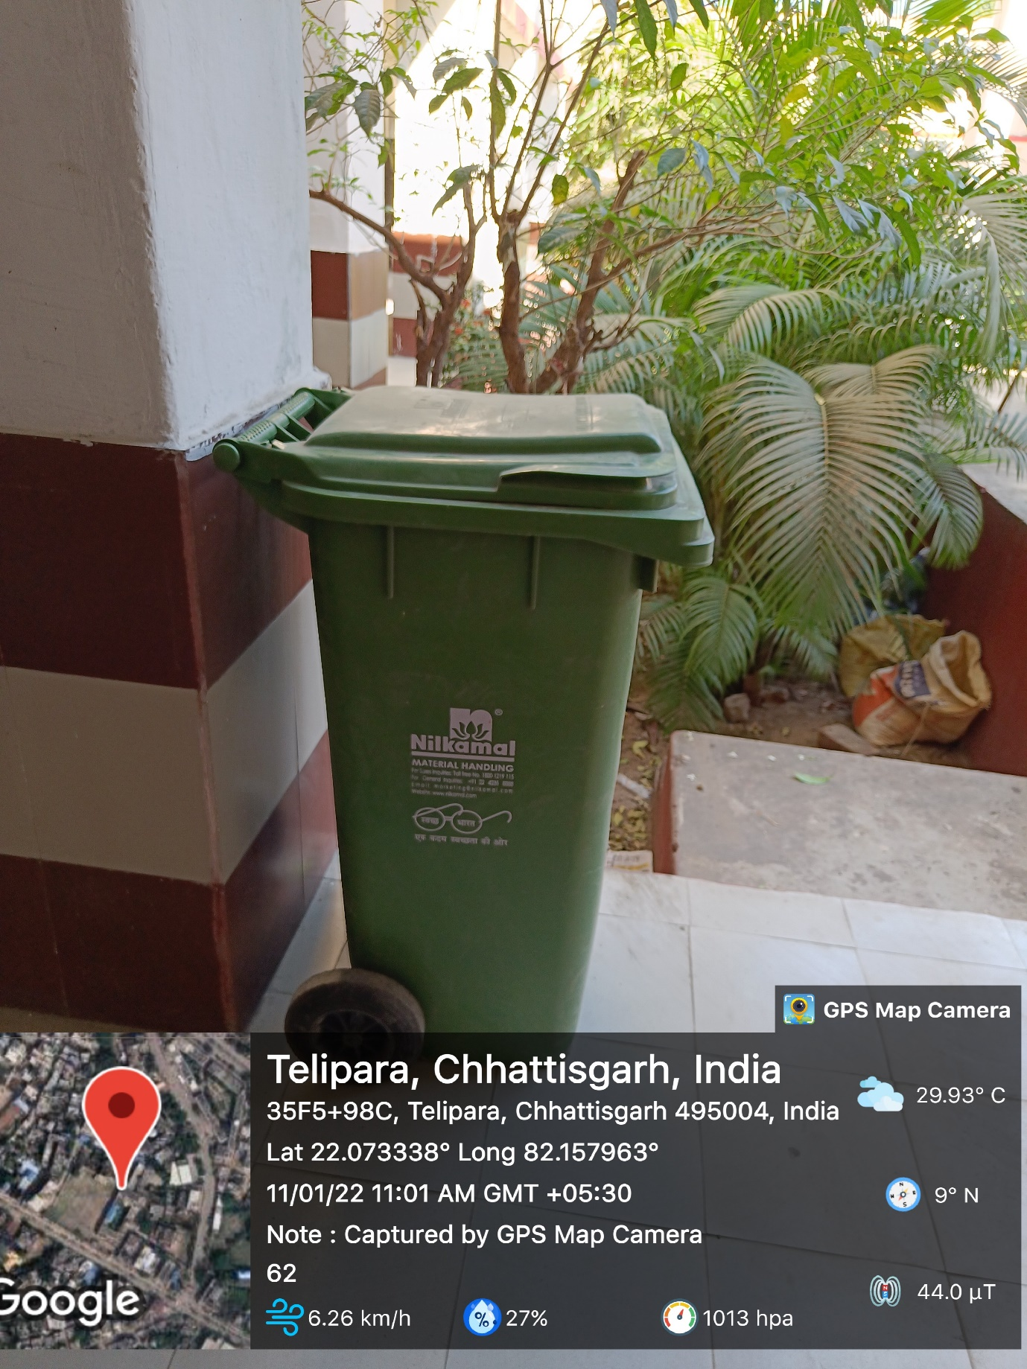

PLASTIC BANED CAMPUS

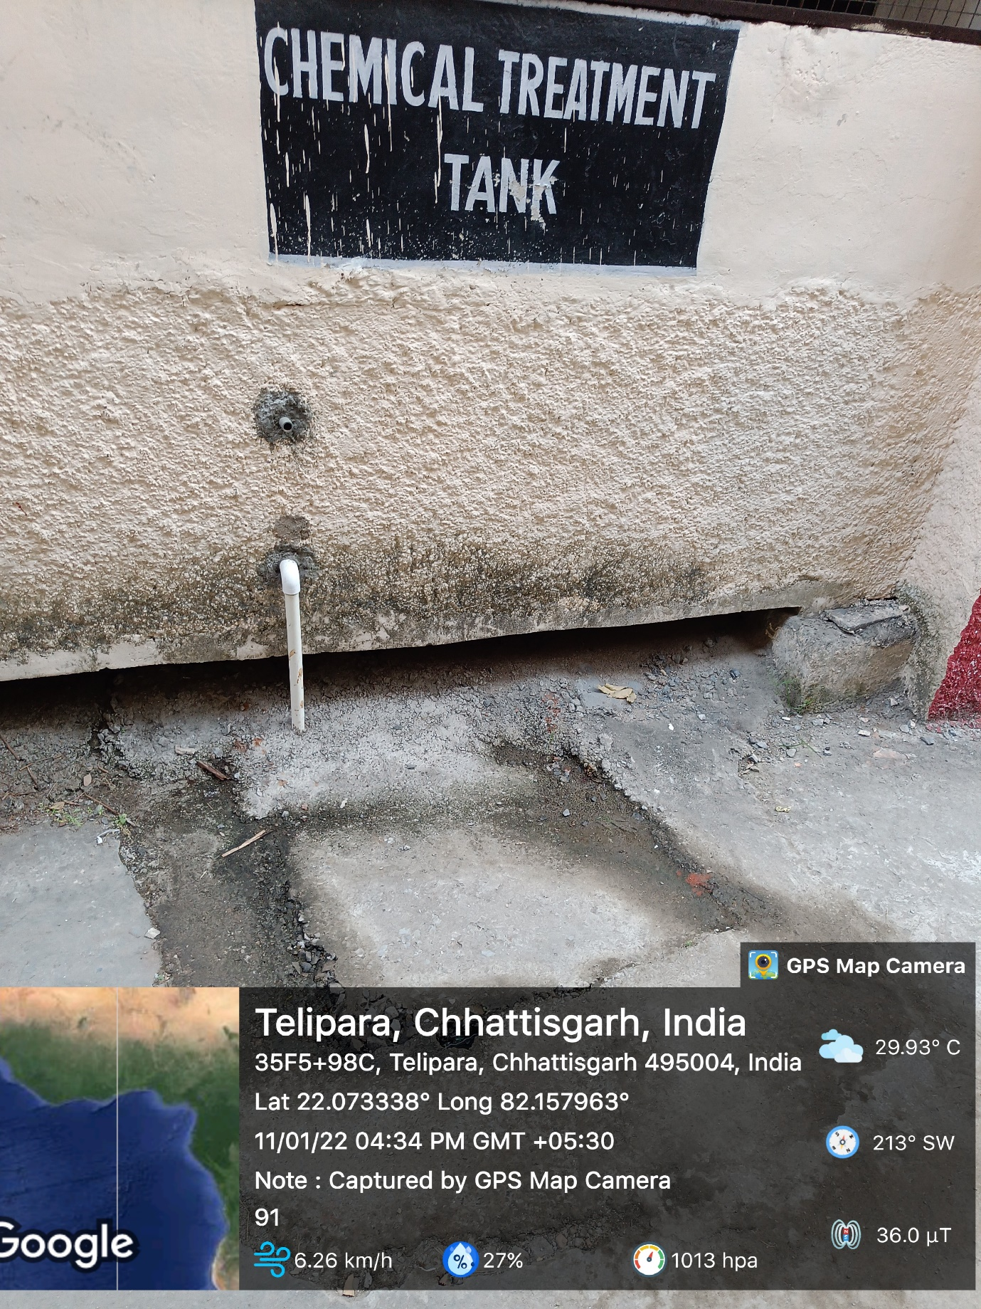

CHEMICAL TREATMENT TANK

